Week 1: Local Environment Setup
Installation and Testing of Local Development Environment
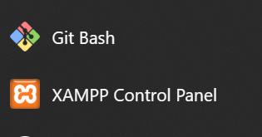
Figure 1: Installation of XAMPP

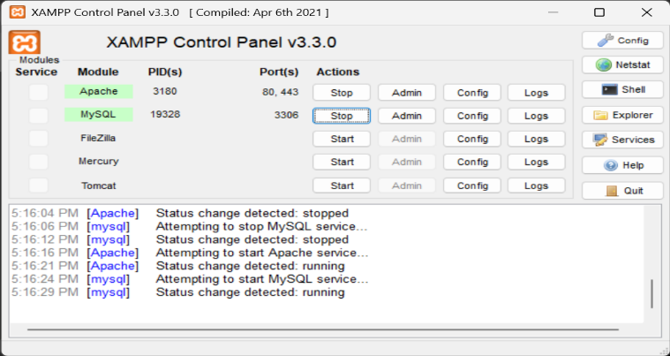
Figure 2: Apache and MySQL Running

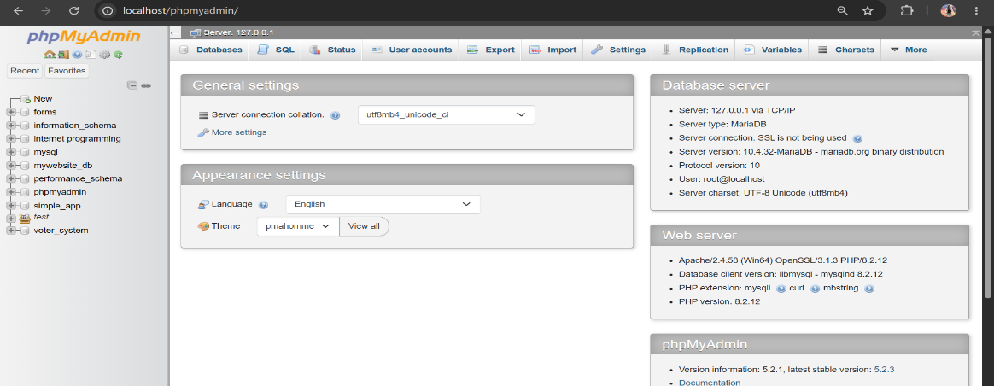
Figure 3: Localhost Test Page

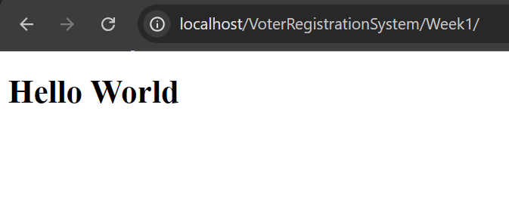
Figure 4: Hello World Test

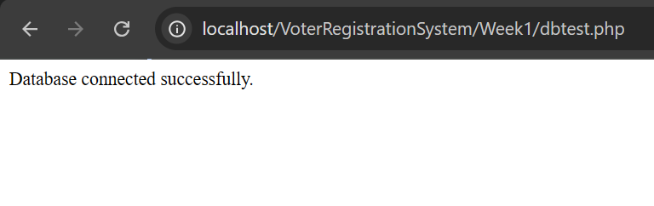
Figure 5: Database Connection Test

